Super Pony Club/Allrounder pony.
14.1hh liver chestnut Welsh X Mare. £2700 ono
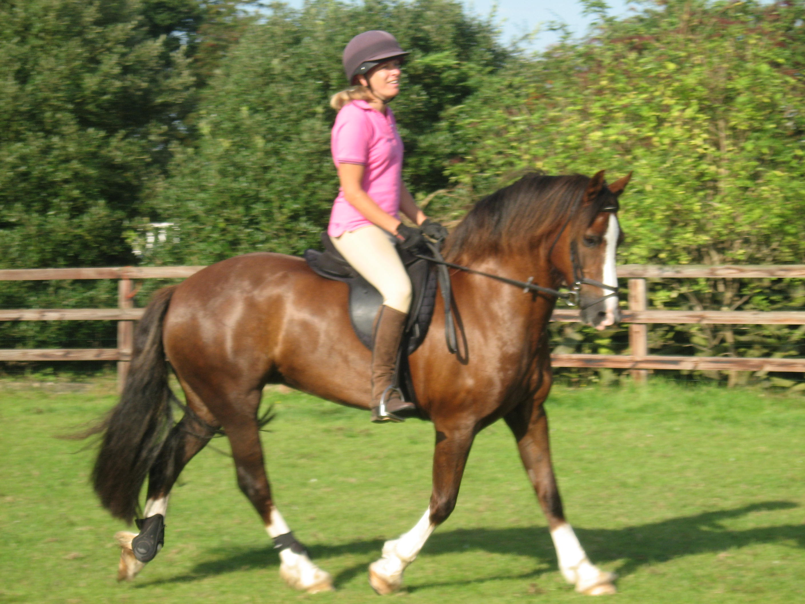
Tia is a super safe pony who could excel in showing or jumping. She has very flashy paces and is a pretty little mare. She loves to jump and will take you round a course of show jumps or X country. Never races into the fences just takes them all in her stride. She can be quick and can turn on a sixpence. She will hack out alone or in company, very good in traffic, never spooky or silly but does get strong so wont suit a novice or nervous rider. She has been taken away on camp and settles into a new environment happily. She has done some gymkhana games and team riding, nothing phases her. Tia is 12 years old and has been with us for 2 years. She is for sale through no fault of her own. Current jockey has a new baby and she is wasted in the field! Tia needs a 5* home that will compete and take full advantage of her sweet and willing nature. Would suit a mother daughter share. She can live in or out, good to shoe, catch, handle and travels well. Sold with nearly new saddle and bridle and complete wardrobe to live in or out. Very genuine pony not to be missed.
Call Julie Pryer on 07891827199 Or Julia Wilson on 07795818856

